ST. AUGUSTINE GIRLS’ HIGH SCHOOL
FORM 4 (MS. S. ALI)

INTERNET & COMMUNICATIONS TECHNOLOGY

LESSON #3 NOTES

What is a wired network?

A wired network is a system by which devices are connected to each other via wires and cables.

What is a wireless network?

A wireless network is a system by which devices are connected to each other via microwaves and radiowaves.

A client-server network

A server is a computer that contains all the relevant information that is needed on a network. A server shares data and resources (hardware and software) among the computers (clients) on the network.
A file server holds all the relevant files on a network.
A web server holds all the valid websites available.

A client is a computer system that sends requests to the server and waits for the server to respond with the requested file. No information is kept on the clients.

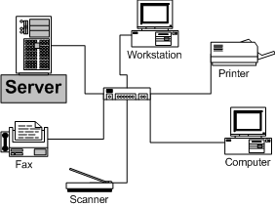

A peer-to-peer network

In a peer-to-peer network, no computer is designated as a server. All the computers share the resources and files that would usually be located only on the server. Computers on this network are considered equal and have the same abilities to use the resources available on the network.
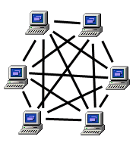

NB: Go to blog and answer the question on client-server and peer-to-peer networks.

TYPES OF NETWORKS

There are three types of networks:

- Local Area Network (LAN)
- Metropolitan Area Network (MAN)
- Wide Area Network (WAN)

Local Area Network (LAN)

Characteristics of a LAN:
- It is confined to a relatively small area – limited to a geographic area such as school or a small group of buildings.
- One computer is designated as the file server.
- In most LANs, cables are used to connect the computers. A wireless LAN (wLAN) can also be set up where no cabling is required.
- Easy to set up
- Cheapest network to set up.

Metropolitan Area Network (MAN)

Characteristics of a MAN:
- The geographical area spans a city or large campus
- Several LANs can be joined wirelessly to form a MAN
- More expensive to set up than a LAN

Wide Area Network (WAN)

Characteristics of a WAN:
- The geographical area spans a country
- Very expensive to set up
- Several MANs are joined wirelessly to form a WAN

